Part A-Basic Join
1.Display the patient name and doctor name for all appointments.
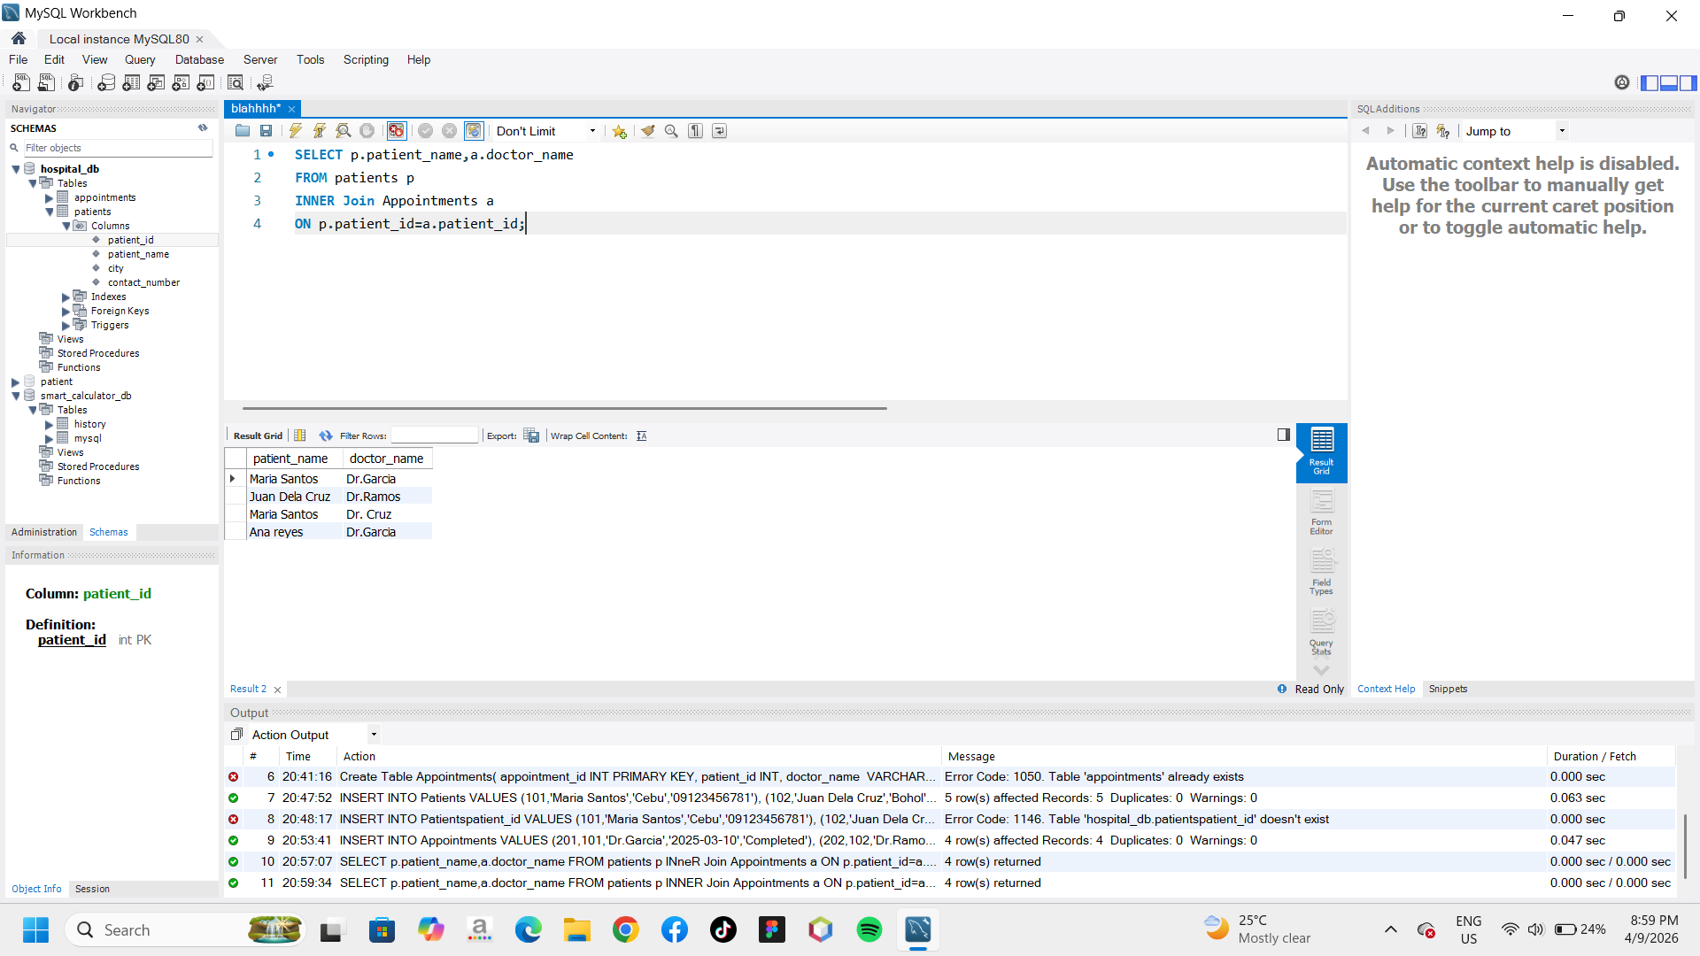

Part B-Filtering with join
2.Display all patients from Cebu and their appointments.
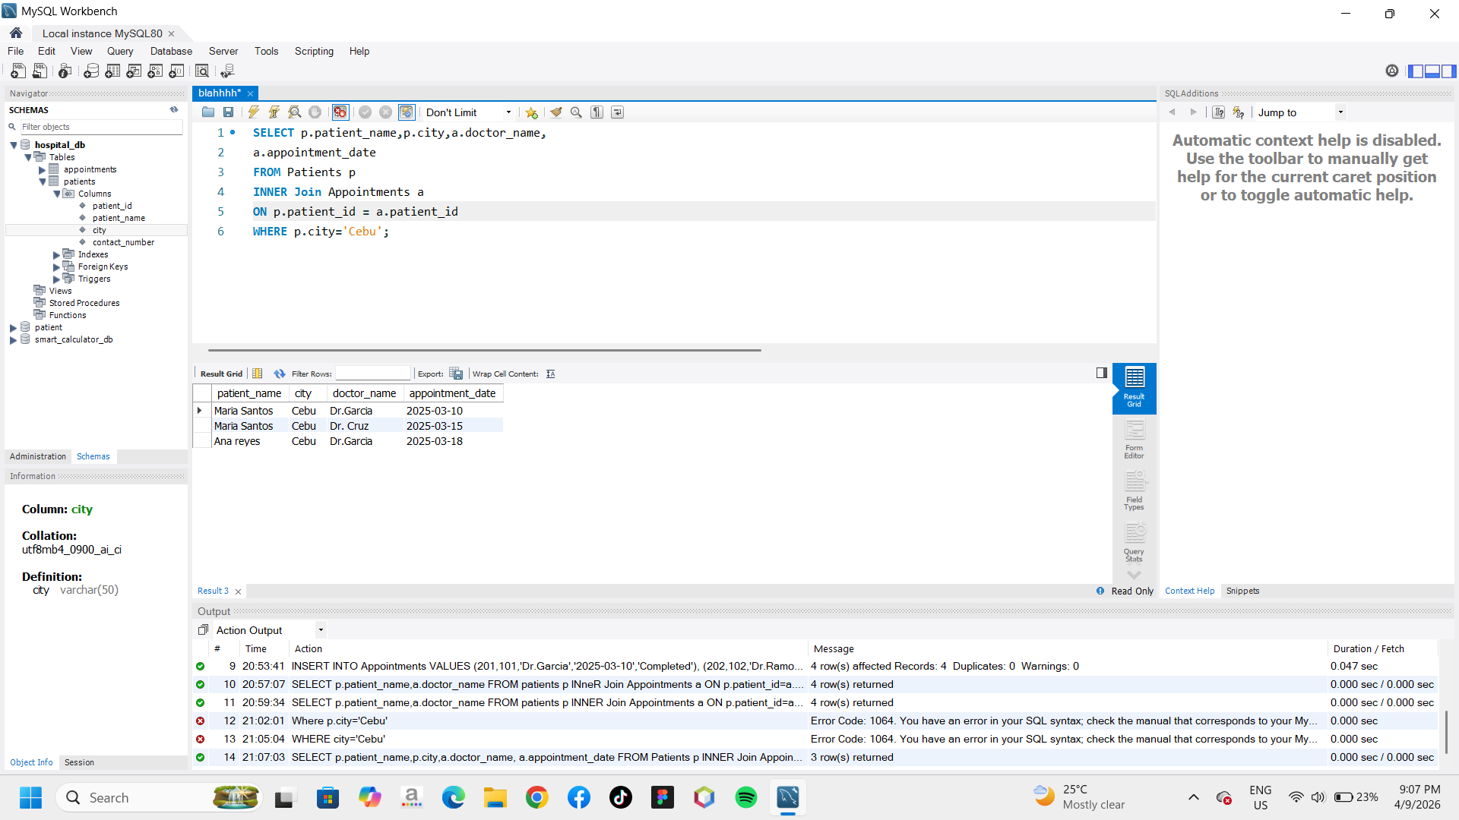

3.Display appointments handled by Dr. Garcia with the patient names.
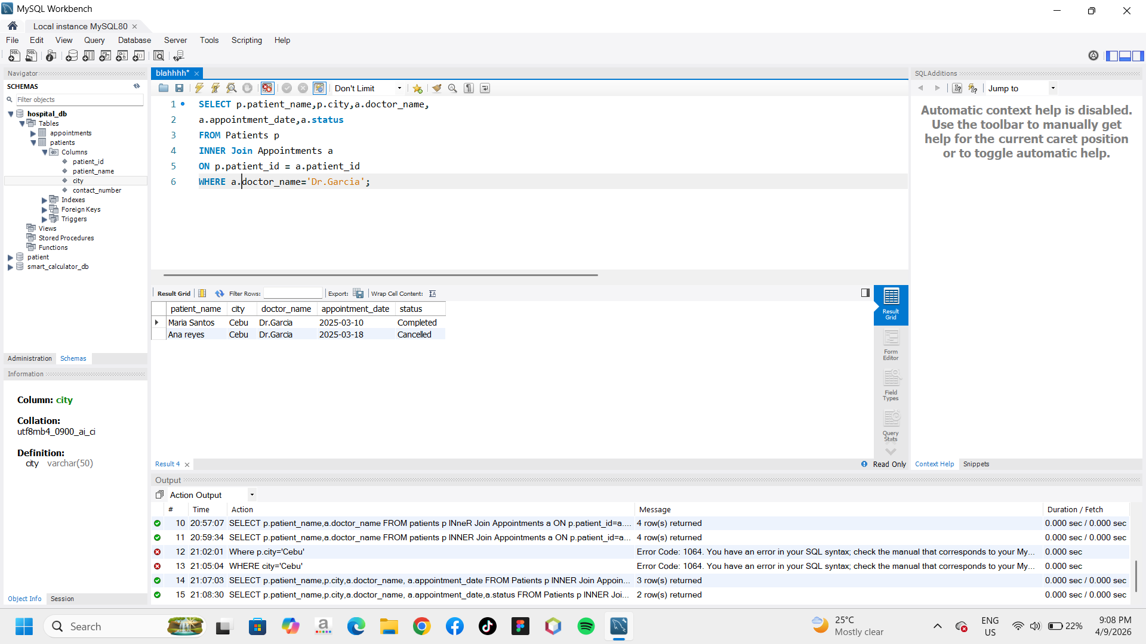
Part C- Analytical Queries
4. Show all patients and their appointments, including patients who do not have
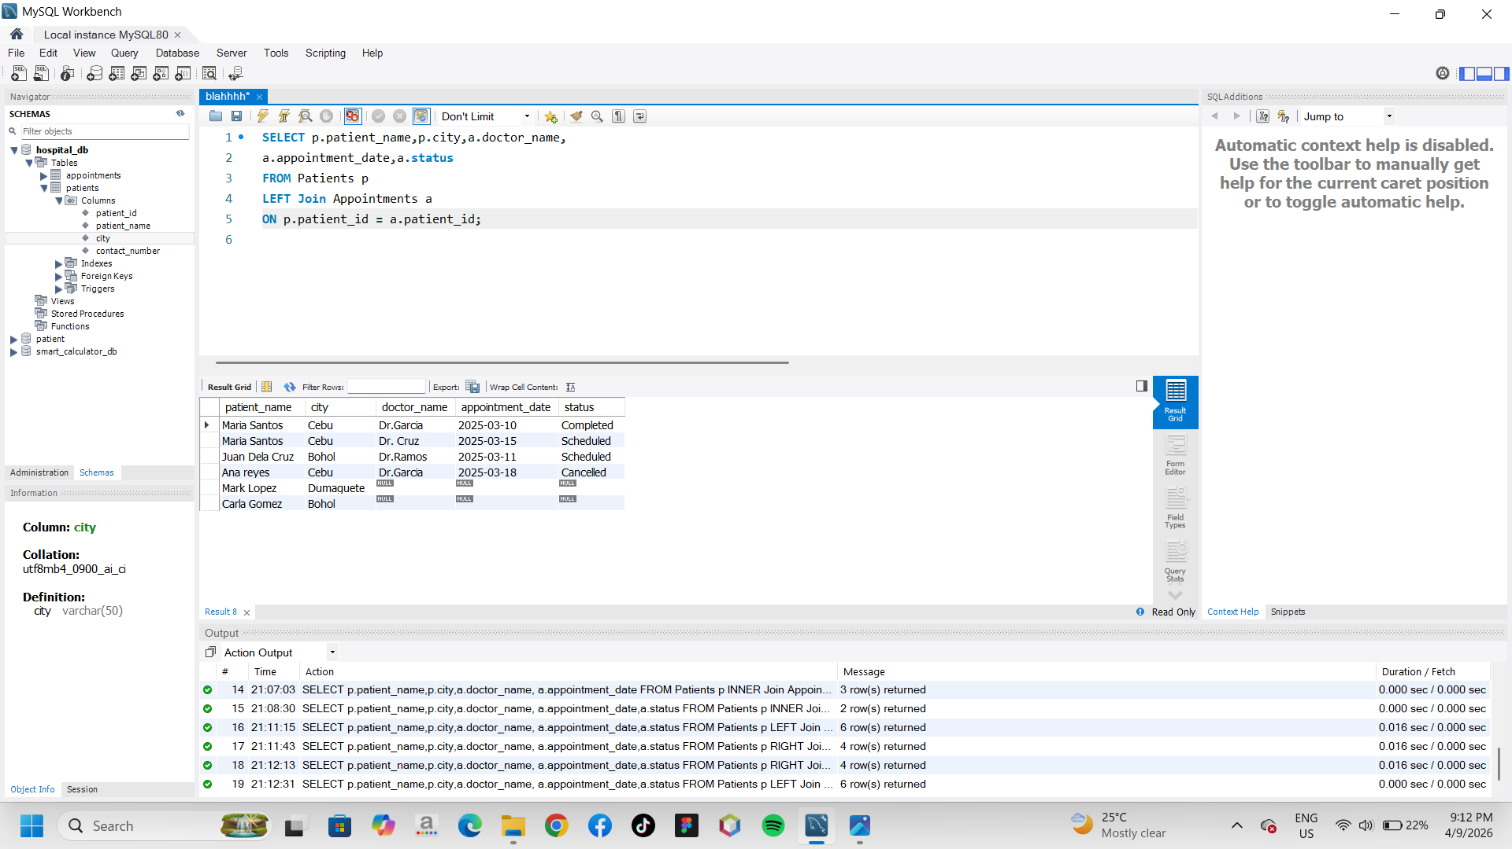
appointments.
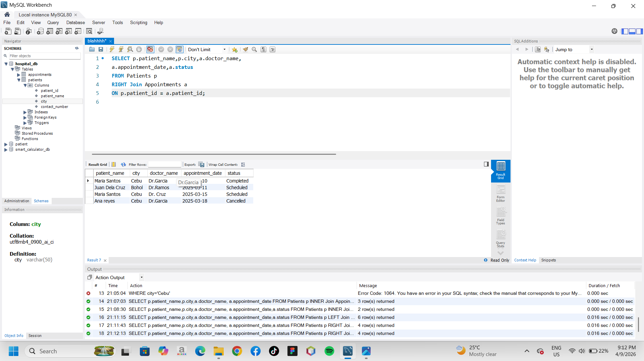
5.Show all appointments even if the patients information does not exist in the Patient table.

